Speaker Information
Author: A.J. BETTS

I am a best-selling, award-winning young adult author with many years of teaching experience. I frequently speak at schools, libraries and festivals. My most popular talks are described below. I hold a current Working with Children Check and speaker’s public liability insurance.

- MEET THE AUTHOR PRESENTATION: This 45-60 minute presentation explores the life of a writer, the nature of creativity, and how I turn small ideas into stories. I share the development of ZAC & MIA, HIVE and ROGUE. This presentation is suitable for students in Years 7 to 12. It is especially relevant for groups studying creative writing, tension, and world-building.

- HIVE PRESENTATION: This 45-60 minute presentation begins by sharing the initial trigger in 2005 that sparked the idea behind HIVE. I then outline the challenges of world-building in speculative fiction, and how I used problem- solving, research and symbolism to build a plausible city structure and a credible society. Topics of character, pace, language and intertextuality are discussed, including the influence of other fictional texts. This presentation is suitable for students in Years 8 to 12. It is especially relevant for groups studying dystopian or science-fiction narratives, world-building, atmosphere and language use.

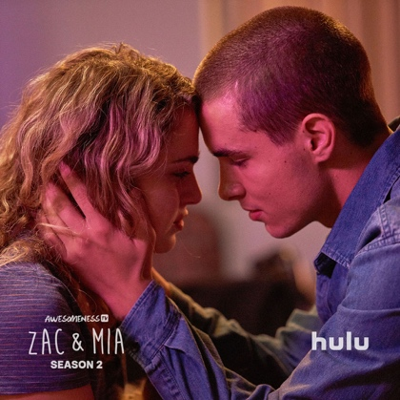
- HIVE/ROGUE ‘STEM’ PRESENTATION: This 45-60 minute presentation explores the overlap between creativity and science. It focuses on the science, technology and engineering influences in HIVE and ROGUE, and how I took current prototypes/ideas and futurist projections to create plausible settings in a future Australia. This presentation is suitable for students in Years 8 to 12, and is especially relevant for groups studying STEM subjects, or those interested in cross-curricular studies/projects.

- ZAC & MIA PRESENTATION: This 45-60 minute presentation explores the intersection of real life factors and how they led to the development of this story. International book covers are shared for comparison, with a discussion of symbolism, themes and marketing. Finally, I share how the novel was adapted into a Hollywood television series, including changes to structure, setting and characterisation. This presentation is suitable for students in Years 8 to 12. It is especially relevant for groups studying real-life themes, realism, visual analysis and book-to-screen adaptations.

- WRITING WORKSHOP: These workshops can range from one hour to a full day. In these practical sessions, I employ fun and accessible activities which emphasise the idea of ‘play’. Using visual stimuli and questions, I lead students through various writing exercises. Students are encouraged to write reflexively, with honesty, courage and empathy. During these workshops, I explain how similar exercises contributed to the development of my novels.

- WRITING CREATIVELY IN EXAM CONDITIONS: In this talk/workshop, I provide practical advice for ATAR students who are anxious about writing under exam conditions. After dispelling myths about creativity, I use a process of questioning to interrogate various visual stimuli and tease out possibilities for story. I’m very flexible and able to cater for specific audiences and requirements.

I have also presented on the following:
- How to harness creativity and wonder (the topic of my recent PhD) in the English classroom
- Writing workshop for adults interested in writing for teenagers
- WAVELENGTH talk
- SHUTTERSPEED talk
- Motivational talks (for graduating tertiary students and employees)

REQUIREMENTS
For talks, a data projector and screen are essential. I can either use my own MacBook and dongle or will bring my PowerPoint saved to a USB to use with a school’s computer. For workshops, I would appreciate use of a whiteboard also.

FEES
For Schools:

 | In-person visit | Virtual visit
1 hour presentation | $350 (plus GST & travel) | $300 (plus GST)
2 x hour presentations | $550 (plus GST & travel) | $500 (plus GST)
3 x hour presentations | $750 (plus GST & travel) | $650 (plus GST)
4 x hour presentations | $880 (plus GST & travel) | $800 (plus GST)

For interstate travel, flights and accommodation will also be required. If multiple schools wish to book me for an interstate period, these additional costs may be shared.

For public events, I am guided by the fees suggested by the Australian Society of Authors. Please go to https://www.asauthors.org/findananswer/rates-of-pay#SCHOOL%20APPEARANCES.

BIOGRAPHY
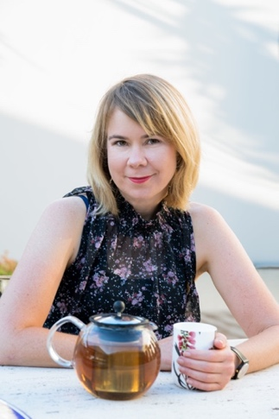
A.J. Betts is an Australian author, speaker, teacher, columnist and cyclist. Her latest novels are HIVE and ROGUE (Pan Macmillan Australia; 2018, 2019) which make up a speculative fiction duology for young adults. Set in an underwater society, HIVE tells the story of Hayley, a fifteen-year-old beekeeper who comes to learn the perilous truths of her world. The novel explores themes of power, friendship, secrecy, sustainability and sacrifice. HIVE was shortlisted for the ABIAs, the INDIE book awards, and the Gold Inky awards, and is a notable book in the 2019 CBCA awards. ROGUE continues the story in a future Australia.

A.J.'s bestselling third novel, ZAC & MIA, won the 2012 Text Prize, the 2014 SCBWI Crystal Kite Award, and the 2014 Ethel Turner prize for young adults at the New South Wales Premier’s Literary Awards. ZAC & MIA is available in 14 countries. Its American television adaptation by AwesomenessTV in 2017/18 won two Daytime Emmy Awards in 2018, and is now available on iTunes Australia.

All of A.J.’s novels have teaching resources – please visit www.ajbetts.com for more information. Her earlier novels are WAVELENGTH and SHUTTERSPEED. A.J. is originally from Queensland but has lived in Perth since 2004. In 2019, she was awarded the Western Australian Writer’s Fellowship at the Premier’s Literary Awards.

FOLLOW
Website: www.ajbetts.com Email: amandajbetts@gmail.com
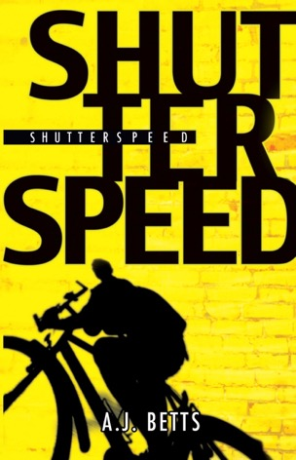
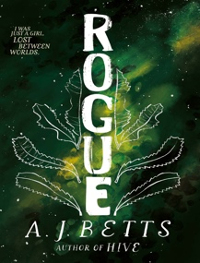
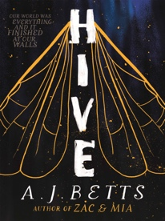
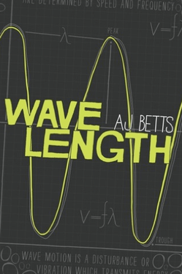
Instagram: ajbettswrites Twittter: a_j_betts Facebook: AJBettsAuthor
