I frequently speak at schools, libraries and festivals. My most popular talks are described below. I hold a current Working with Children Check and speaker’s public liability insurance.
1. MEET THE AUTHOR PRESENTATION: This 60-minute presentation explores the nature of creativity and the truth of the storytelling process. I share some of my early live/work before focusing on ZAC & MIA – its real-life backstory, fictional narrative, and its international impact. I conclude by outlining the backstory of HIVE and ROGUE, and how the world-building and narrative evolved from curiosity. This presentation is suitable for students in Years 7 to 12. It is especially relevant for groups studying creative writing, tension, world-building, visual analysis and adaptations from book to screen.
2. HIVE PRESENTATION: This 60-minute presentation begins with the backstory of HIVE: how real-life stimulus in 2005 triggered ‘what if’ questions which laid the foundations of the story. I then outline the challenges of world-building in speculative fiction, and how I used problem-solving, research and symbolism to build a plausible city structure and a credible society. Topics of character, pace, language and intertextuality are discussed, including the influence of other fictional texts. This presentation is suitable for students in Years 8 to 12. It is especially relevant for groups studying dystopian narratives, world-building, and/or characterisation.
3. ZAC & MIA PRESENTATION: This 60-minute presentation explores the intersection of real-life factors and how they led to the development of the narrative. I discuss how I weaved conflict into story, and manipulated tension in a difficult setting. I explore how themes evolved through the drafting of the story. International book covers are shared for comparison, with a discussion of symbolism, themes and marketing. Finally, I share how the novel was adapted into a Hollywood television series, including changes to structure, setting and characterisation.
4. WRITING WORKSHOP: These workshops can range from one hour to a full day. In these practical sessions, I employ fun and accessible activities which emphasise the idea of ‘play’. Using visual stimuli and questions, I lead students through various writing exercises, including: writing from real-life stories; writing from setting; and writing character and backstory. Students are encouraged to write reflexively, with honesty and empathy. During these workshops, I explain how similar exercises aided the development of my novels.
5. WRITING CREATIVELY IN EXAM CONDITIONS: In this talk/workshop, I provide practical advice for ATAR students who are anxious about writing under exam conditions. After dispelling myths about creativity, I use a process of questioning to interrogate various visual stimuli and tease out possibilities for story.
I’m very flexible and able to cater for specific audiences and requirements. Other topics include:
- Motivational talks (for graduating tertiary students and employees)
- Creativity and wonder (topic of my recent PhD)
- Character development
- WAVELENGTH talk
- SHUTTERSPEED talk
- Writing workshop for adults interested in writing for teenagers

REQUIREMENTS
For talks, a data projector and screen are essential. I can either use my own MacBook and dongle or will bring my PowerPoint saved to a USB to use with a school’s computer. For workshops, I would appreciate use of a whiteboard. Data projector and screen are preferable, but not essential.

FEES
I am guided by the recommended rates outlined by the Australian Society of Authors. For schools, these are:
$350 for 1 x 60-minute session
$400 for 1 x 90-minute session
$500 for half day (2 x 60 minutes)
$650 full day (3 x 60 minutes)
$800 full day (4 x 60 minutes)
I am not registered for GST.
Public appearance rates (eg, for libraries and festivals) can be found on the ASA website. For interstate travel, flights and accommodation will also be required. If multiple schools are booking me for an interstate period, these additional costs may be shared.

BIO

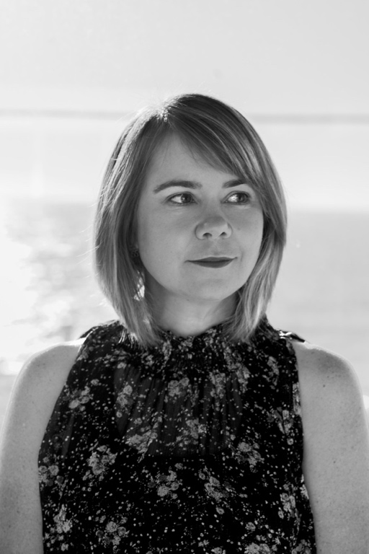
A.J. Betts is a Fremantle-based author, speaker, teacher and cyclist. Her latest novels are HIVE and ROGUE (Pan Macmillan Australia) which comprise a speculative fiction duology for young adults. Set in an underwater society, HIVE (2018) tells the story of Hayley, a fifteen-year-old beekeeper who comes to learn the perilous truths of her world. The novel explores themes of power, friendship, secrecy, sustainability and sacrifice. HIVE was shortlisted for the ABIAs and the INDIE book awards, longlisted for the INKYs, and was a notable book in the 2019 CBCA awards. ROGUE (2019) continues the story in a future Australia.

A. J.'s bestselling third novel, ZAC & MIA, won the 2012 Text Prize, the 2014 SCBWI Crystal Kite Award, and the 2014 Ethel Turner prize for young adults at the New South Wales Premier’s Literary Awards. ZAC & MIA is available in 14 countries. Its American television adaptation by AwesomenessTV in 2017/18 won two Daytime Emmy Awards in 2018. A. J.’s earlier novels are WAVELENGTH and SHUTTERSPEED. A.J. is originally from Queensland but has lived in Perth since 2004.

In her presentations, A.J. draws on her recent PhD (which investigates the nature and value of wonder, particularly in fiction) and her twenty-plus years of teaching experience to offer generous insights into creativity and storytelling. She is an entertaining and engaging speaker for secondary students and adults.

